UNIFORM – CURRENT SCHOOL STANDARD

- Uniform
- Regulation school skirt (girls) or shorts (boys)
- Regulation school white blouse (girls) and grey shirt (boys)
- Polar fleece
- Regulation GIS navy socks or navy tights – tights winter only (girls)
- Regulation grey knee high socks (boys)
- Plain black sandals with heel strap (Terms 1 and 4 only). NO SOCKS.
- Boys - clean black leather lace up shoes (not boots/sports shoes)
- Girls - clean black leather lace up shoes. (no ballet flats/boots/sports shoes)
- Regulation school PE shirt
- Regulation school PE shorts
- Sports shoes and socks.
- School cap

- Optional Gear
- Jacket – school regulation jacket only – not to be worn indoors
- Black or blue scarf (not to be worn indoors)
- NO BEANIES

- Jewellery
- None – except one pair of plain gold or silver stud earrings and a watch. NO coloured stones. NO plugs.
- Bone carvings, religious chains etc are to be worn under uniform
- Parents/ caregivers should send a letter to the principal to apply for permission to wear these items

- Hair
- Tied back off face – if it touches the shoulder it should be tied up
- Plain black, white or navy blue hair ties
- Plain black, navy blue or white hair band
- Plain hair slides - (eg bows)
- No chalks
- Natural hair colours, no hair dye

- Nails
- Clear nail polish to be worn only

- General
- If singlets etc. are worn under uniform, they are not to be visible
- PE gear not to be worn under uniform
- PE must be done in PE gear
- Polar fleeces should not be worn during PE or assemblies (unless in cold weather)
- All uniform items must be named
- No mixing of PE and school uniform
- Sandals or socks and shoes must be worn with Number 1 Uniform
- Sports shoes are encouraged to be worn for PE and recreational sporting activity. Sports shoes must be worn when representing the school in sport.
- If sports shoes and socks are not worn with PE gear, this is at own risk
- Number 1 Uniform to be worn to and from school. PE uniform may be worn home on a Friday after sport only

GIS UNIFORM

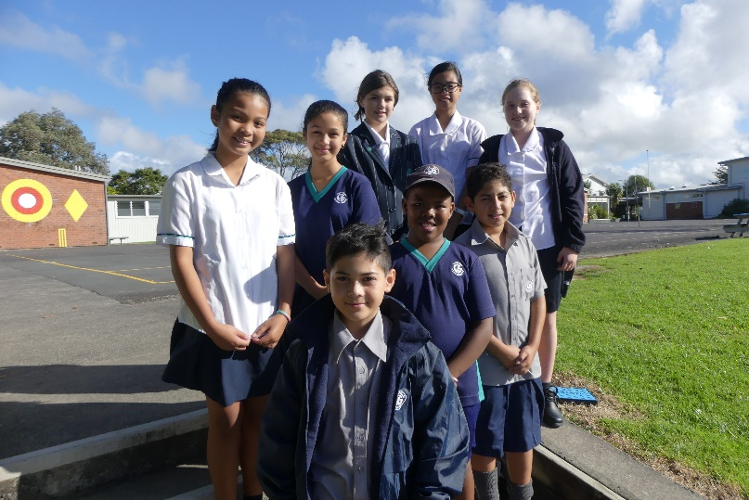

Polar Fleece Jacket Cap Girls Socks
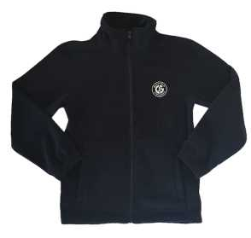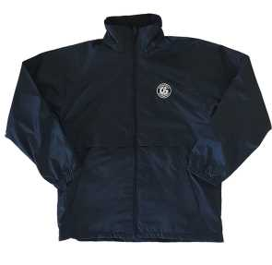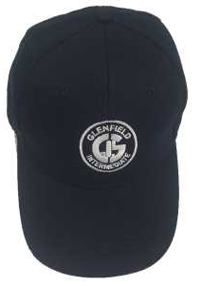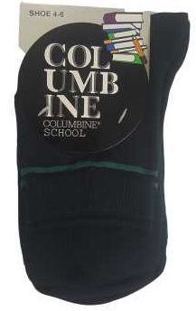

Girls Blouse Girls Skirt Girls Culotte Girls Shoes
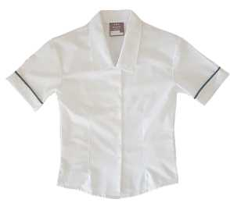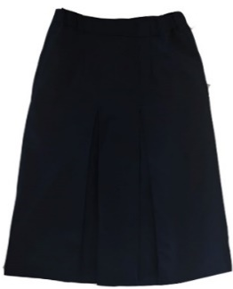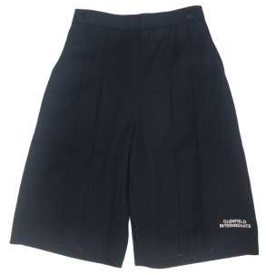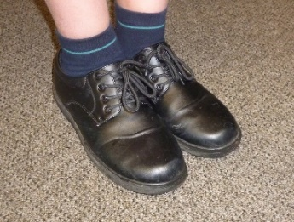

Boys Shirt Boys Shorts Boys socks Boys Shoes
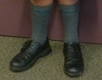
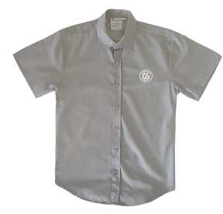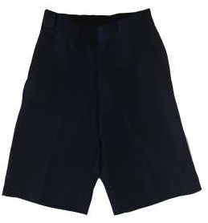

PE Top PE Shorts
