Communication with the School

The school uses several ways of communicating information to parents, the main form is through the School App. To register for the School app, please follow the instructions below;
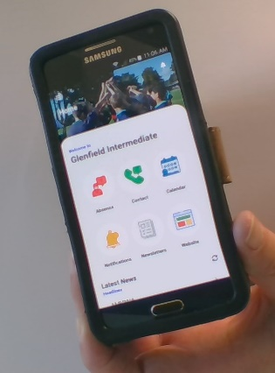
School APP
The school website now includes our School App. To ensure you receive all the latest updates/notices/alerts, please download the new App by using the link on the school website or via the QR code below. These will take you to KiwiSchools Connect, download the KiwiSchools Connect App from the App Store or Play Store. Search for Glenfield Intermediate. When prompted select – Subscribe to all.

Other forms of communication are as follows -
- Website - www.glenfieldint.school.nz
- Email notices to parents via School SMS system - NOTE: If you have recently changed your email address, please contact the school office with your new email.

- Facebook - Glenfield Intermediate School
- Twitter – GlenfieldIntNz
- Seesaw

Note: Absences can be notified directly through our Website or by leaving a message on the school absence line.

